HW3- Building a serverless WebApplication

**HimaBindu Battu**

Step-1

Create an Environment (cis 5755-bindu) in the AWS Cloud9

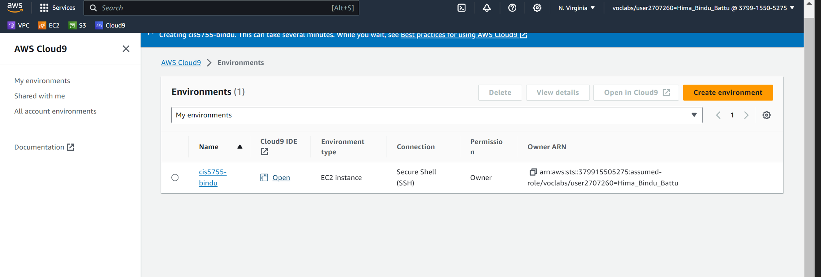

Step-2

Uploading the JavaScript and the Html files and the code to the IDE , Cloud9

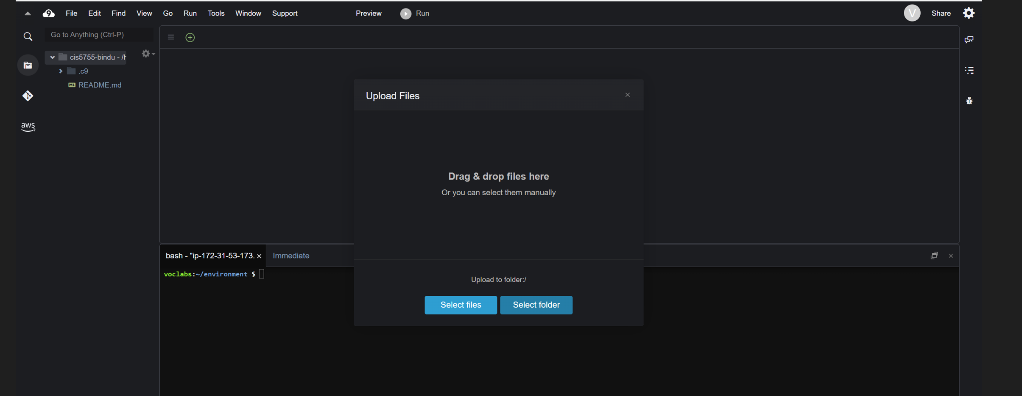

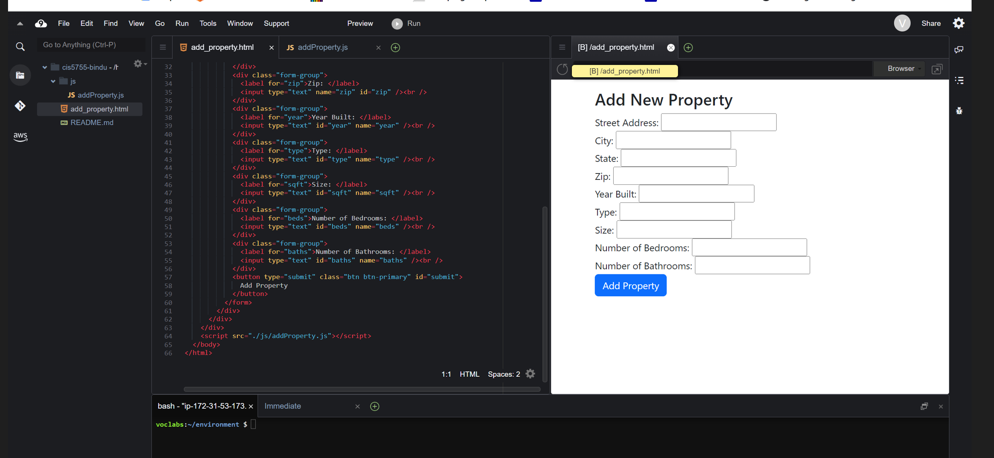

Step-3

Run the table.py to create a table “PropertyBasic” in DyanamoDb

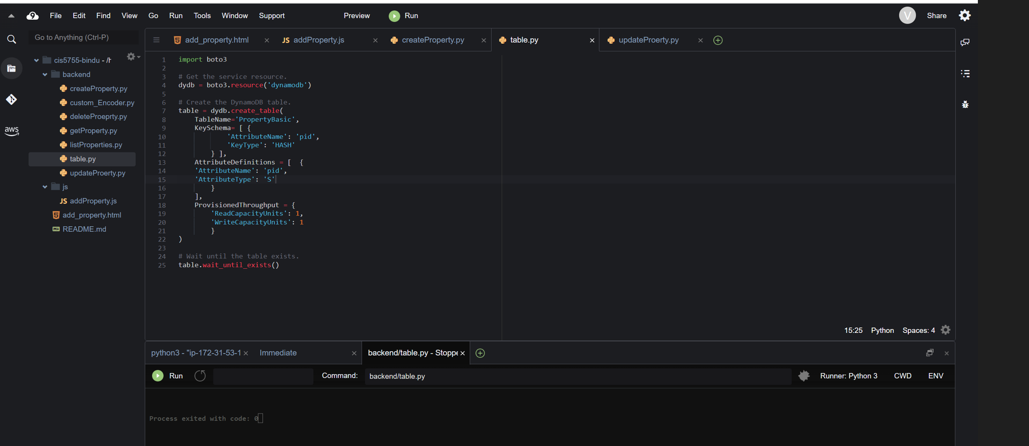

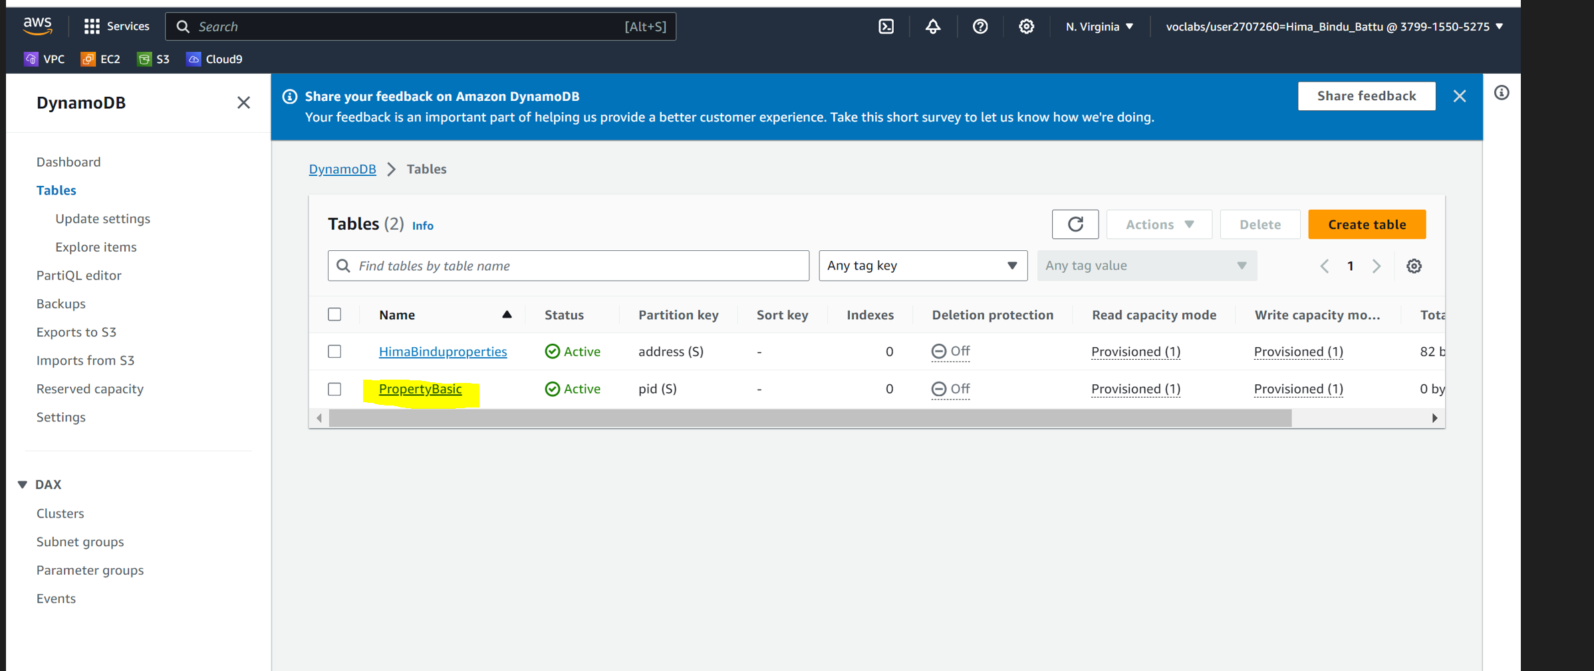

Step-4 Create AWS Lambda Function

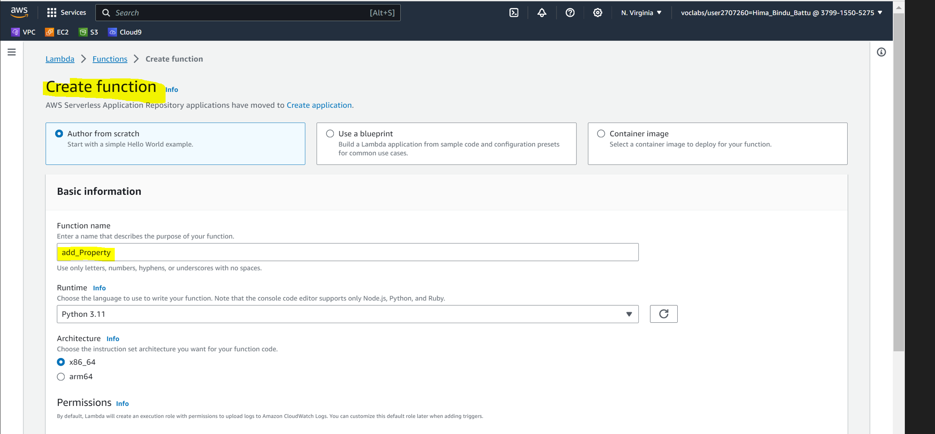

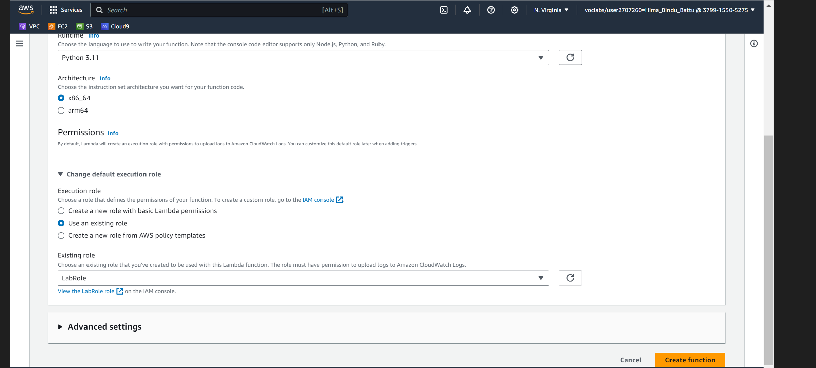

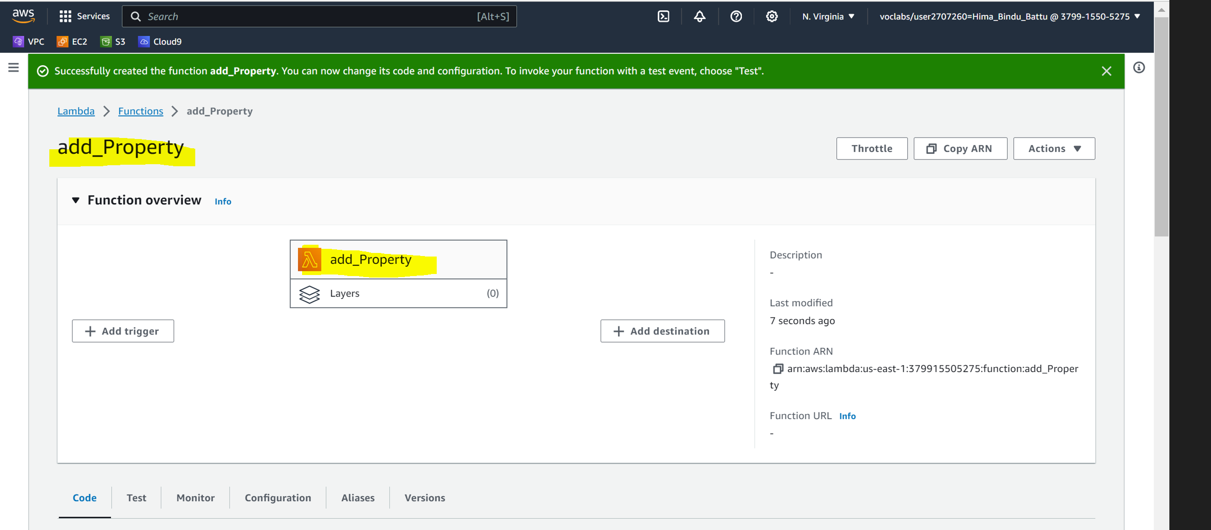

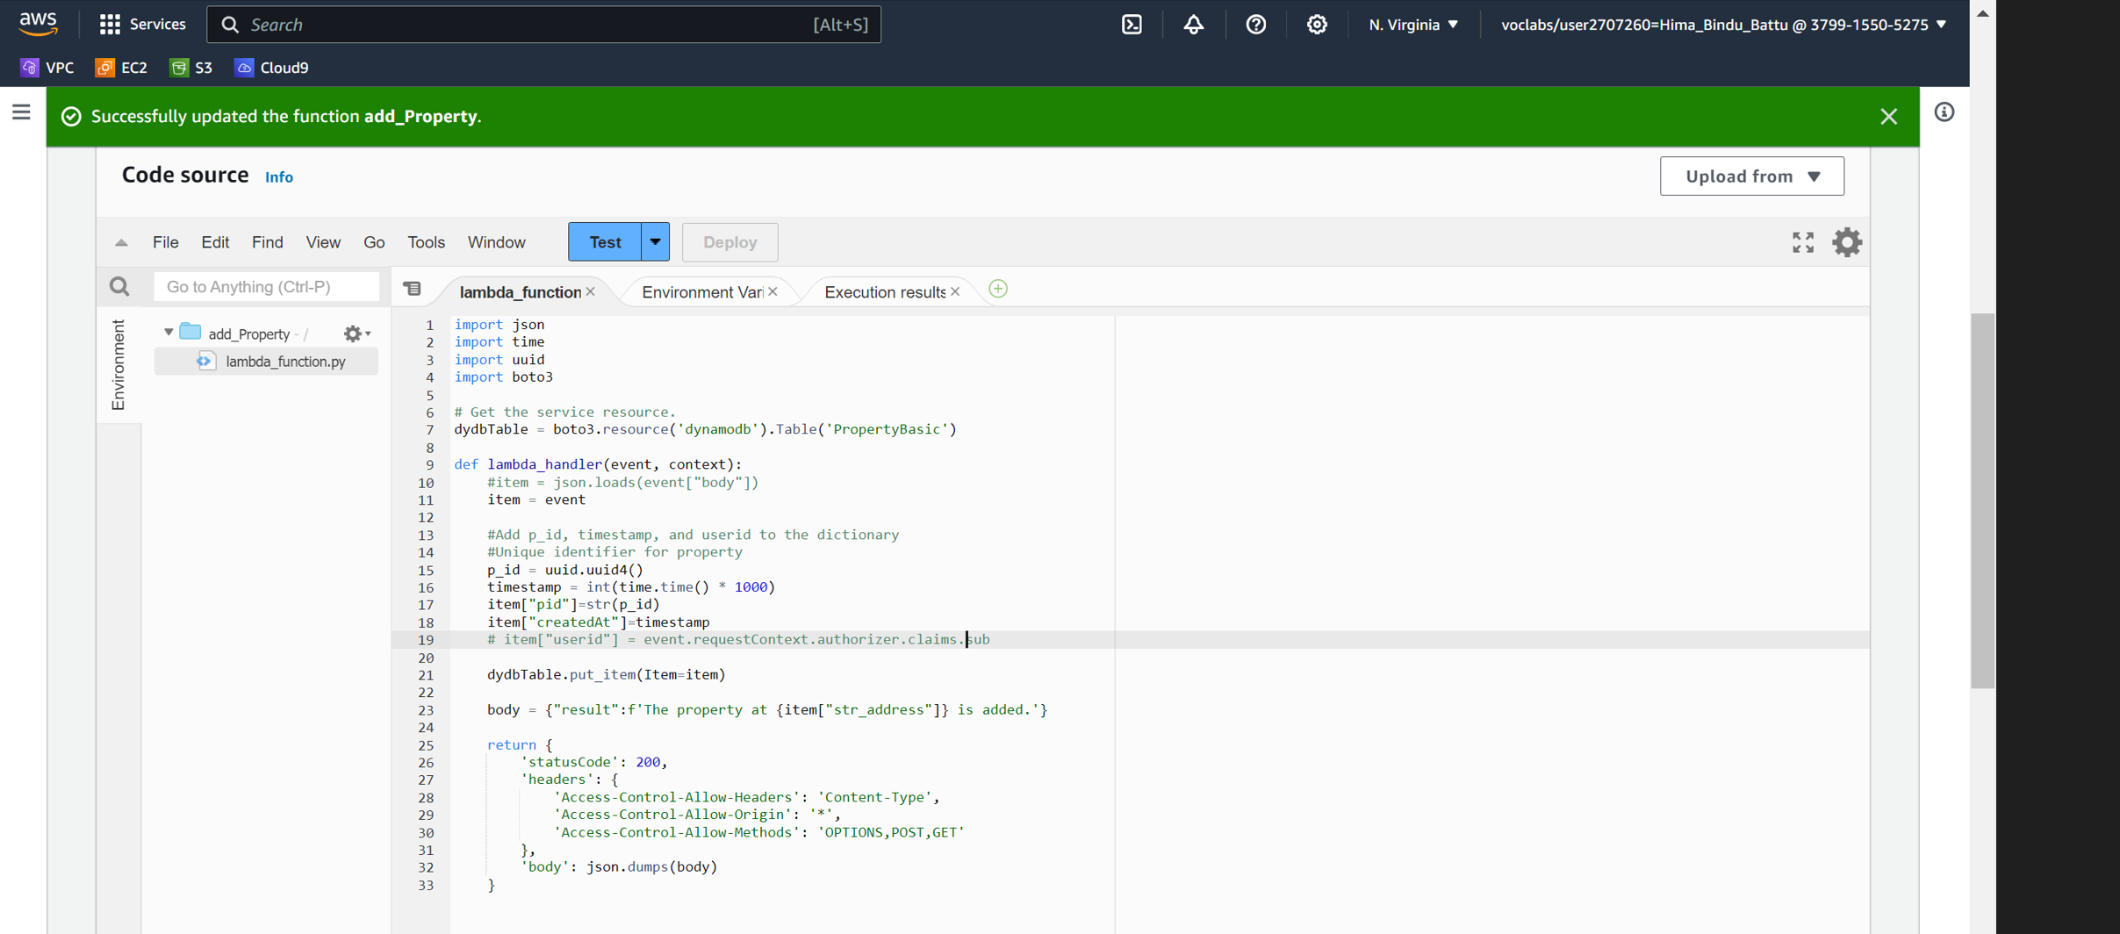

Step-5 Test AWS Lambda Function

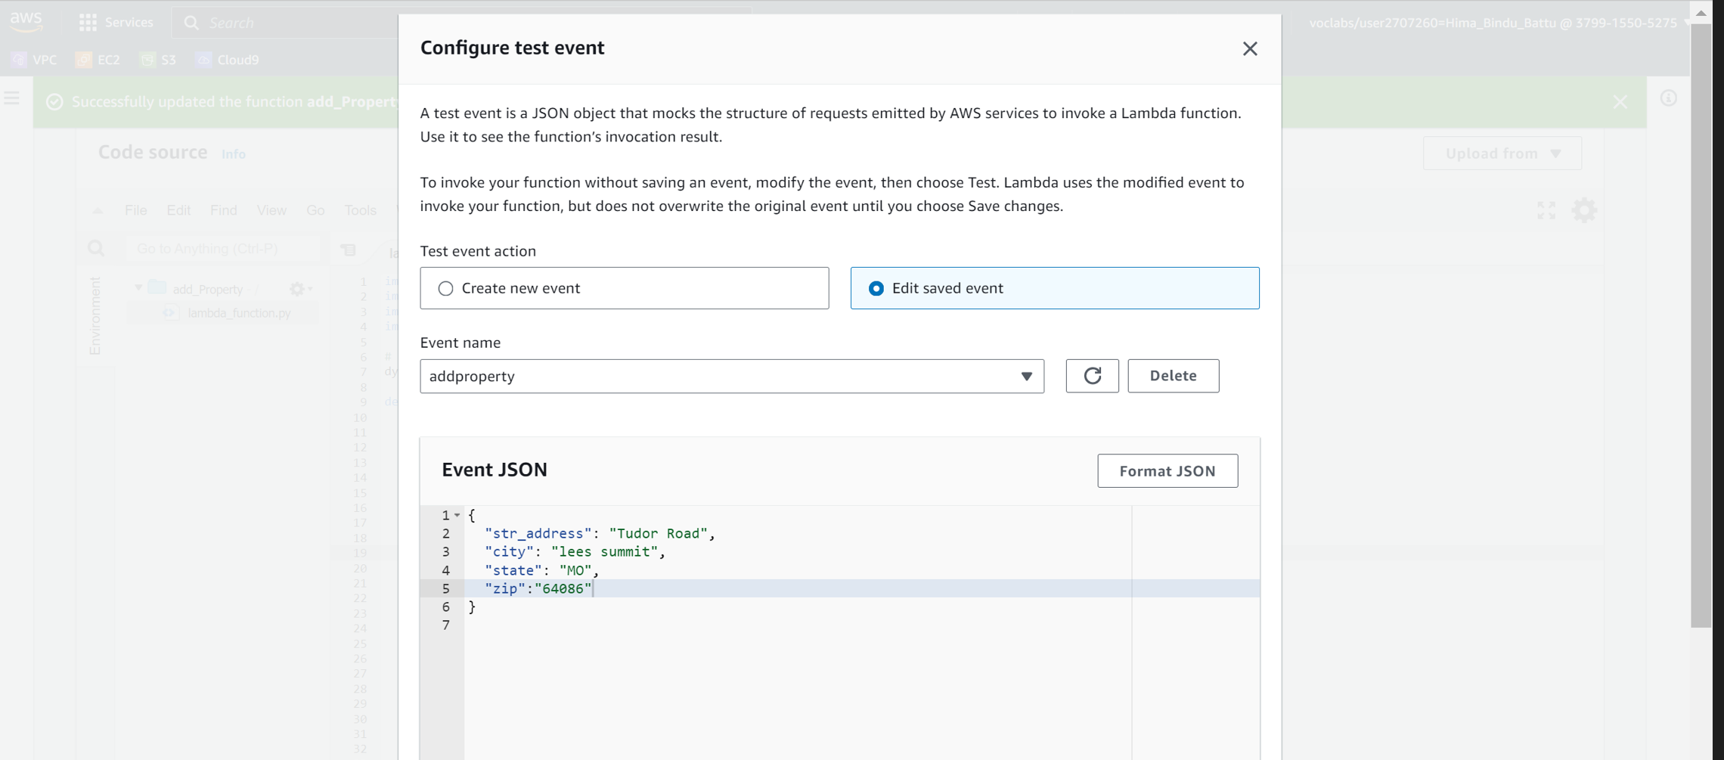

AWS Lambda Function-Test Result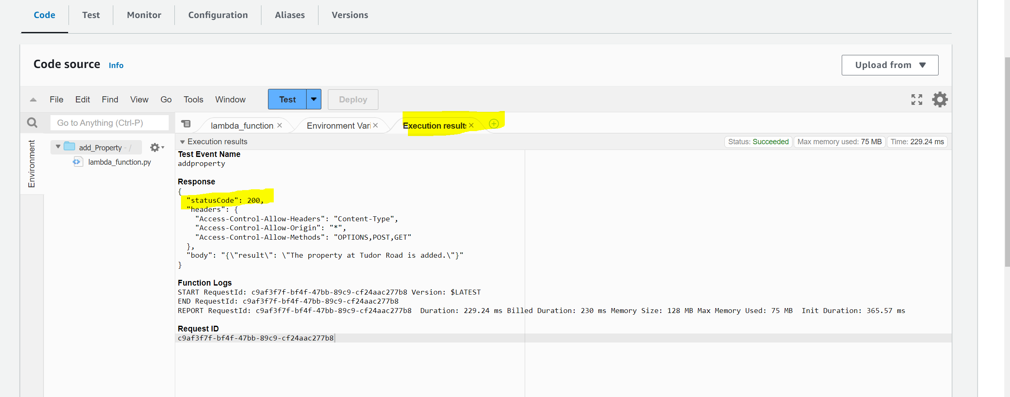

Step-6 Creating REST API by name **property_add**

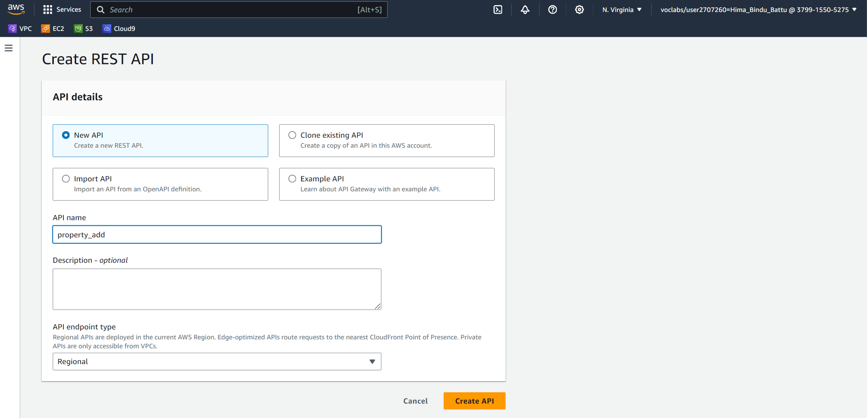

Step-7 Create Resource by name **newproperty and Enable CORS**

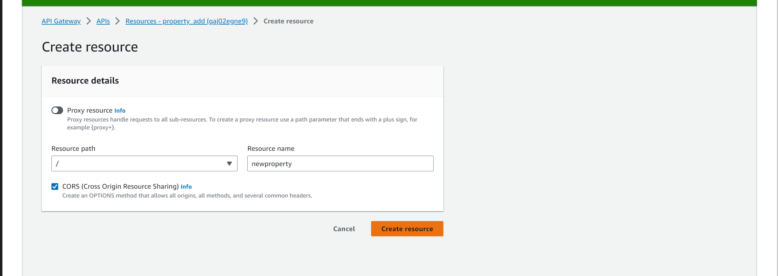

Step-8 Create Method – POST- Create the required Method and choose the appropriate Lambda function

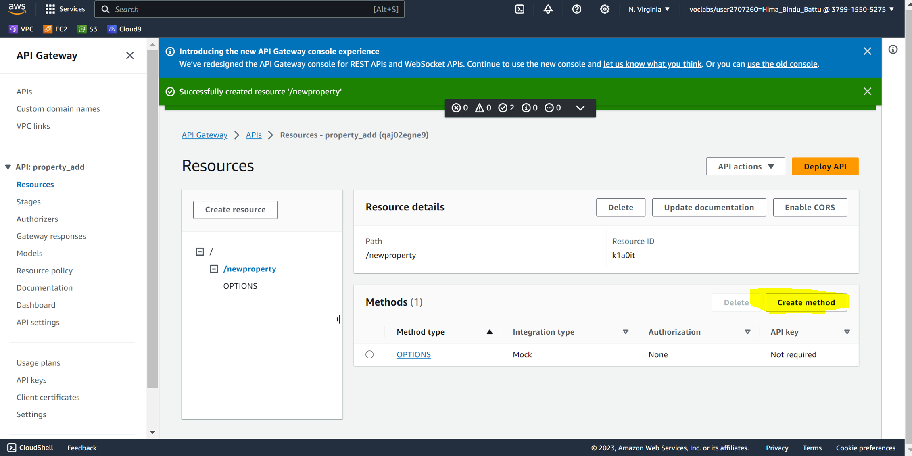

Step-9 Creation of Method “POST” in the API gateway

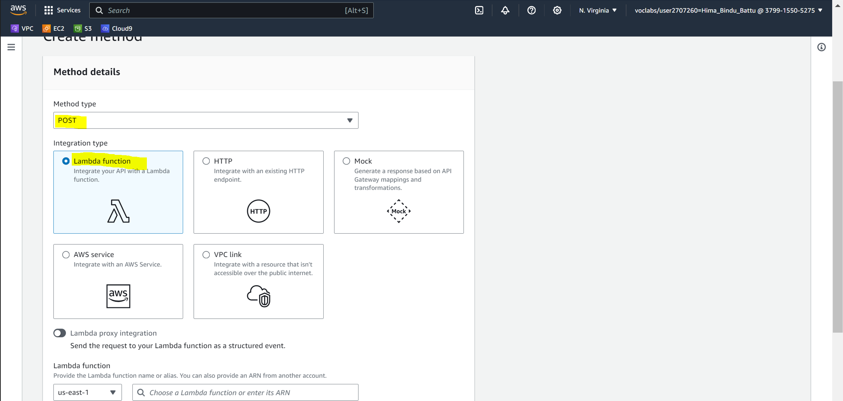

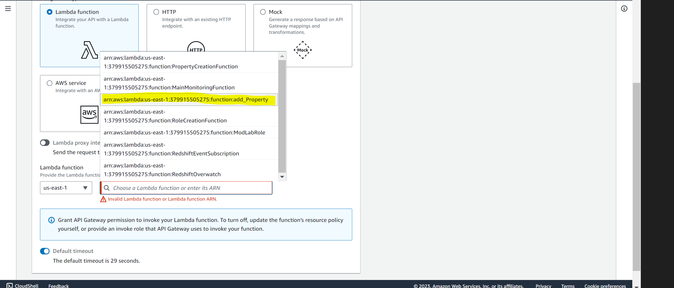

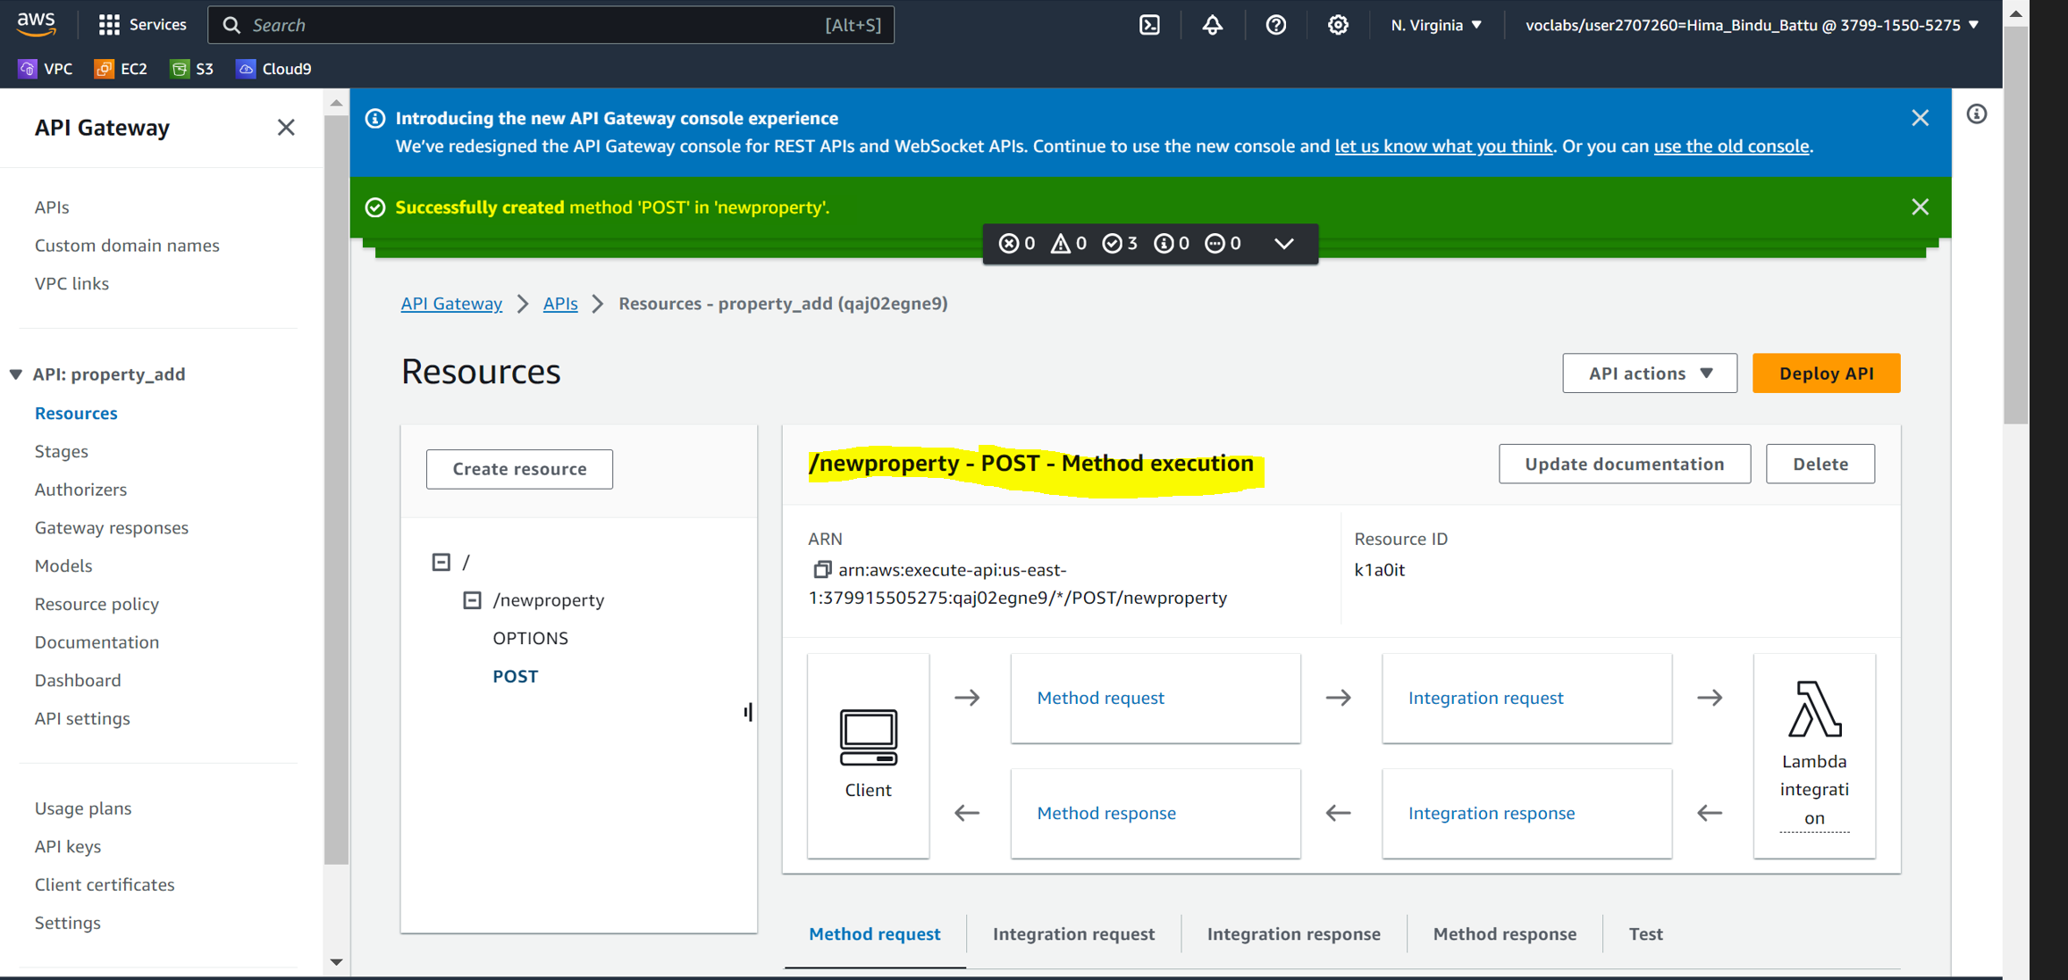

Step-10 Testing for POST Method if the test results are been reflected in the Dyanamo Db

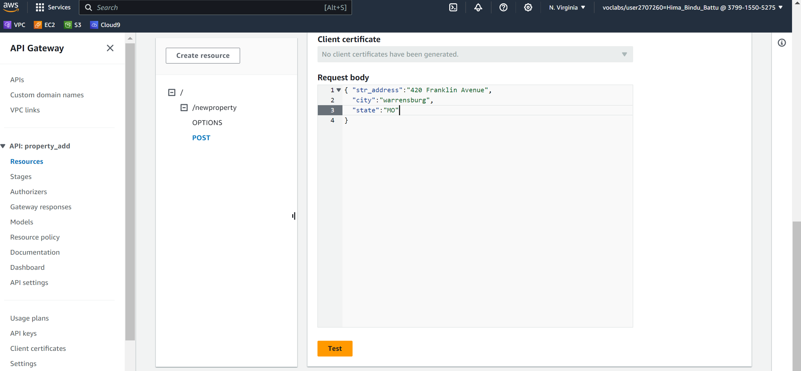

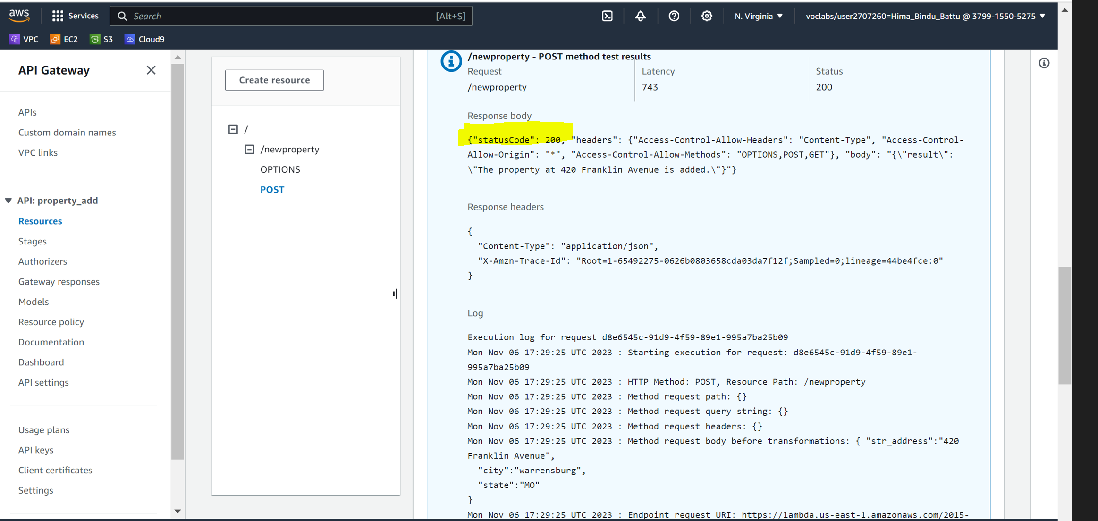

The Test Results for the POST Method are being reflected in the Dyanamo DB

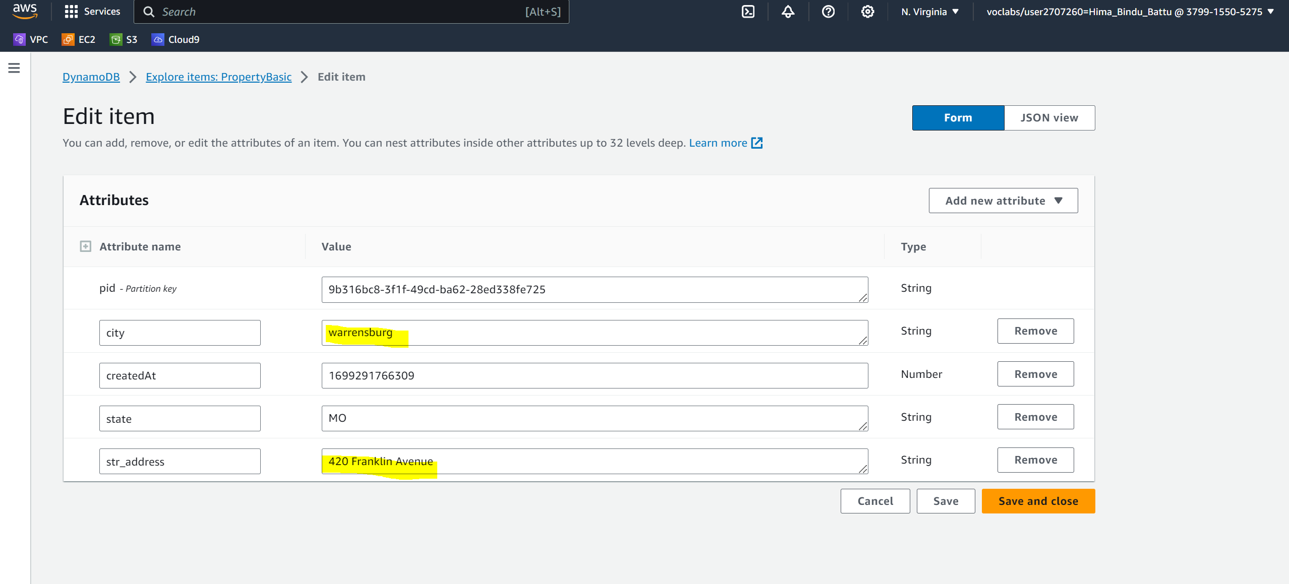

Step-11 Creation of API -Stage

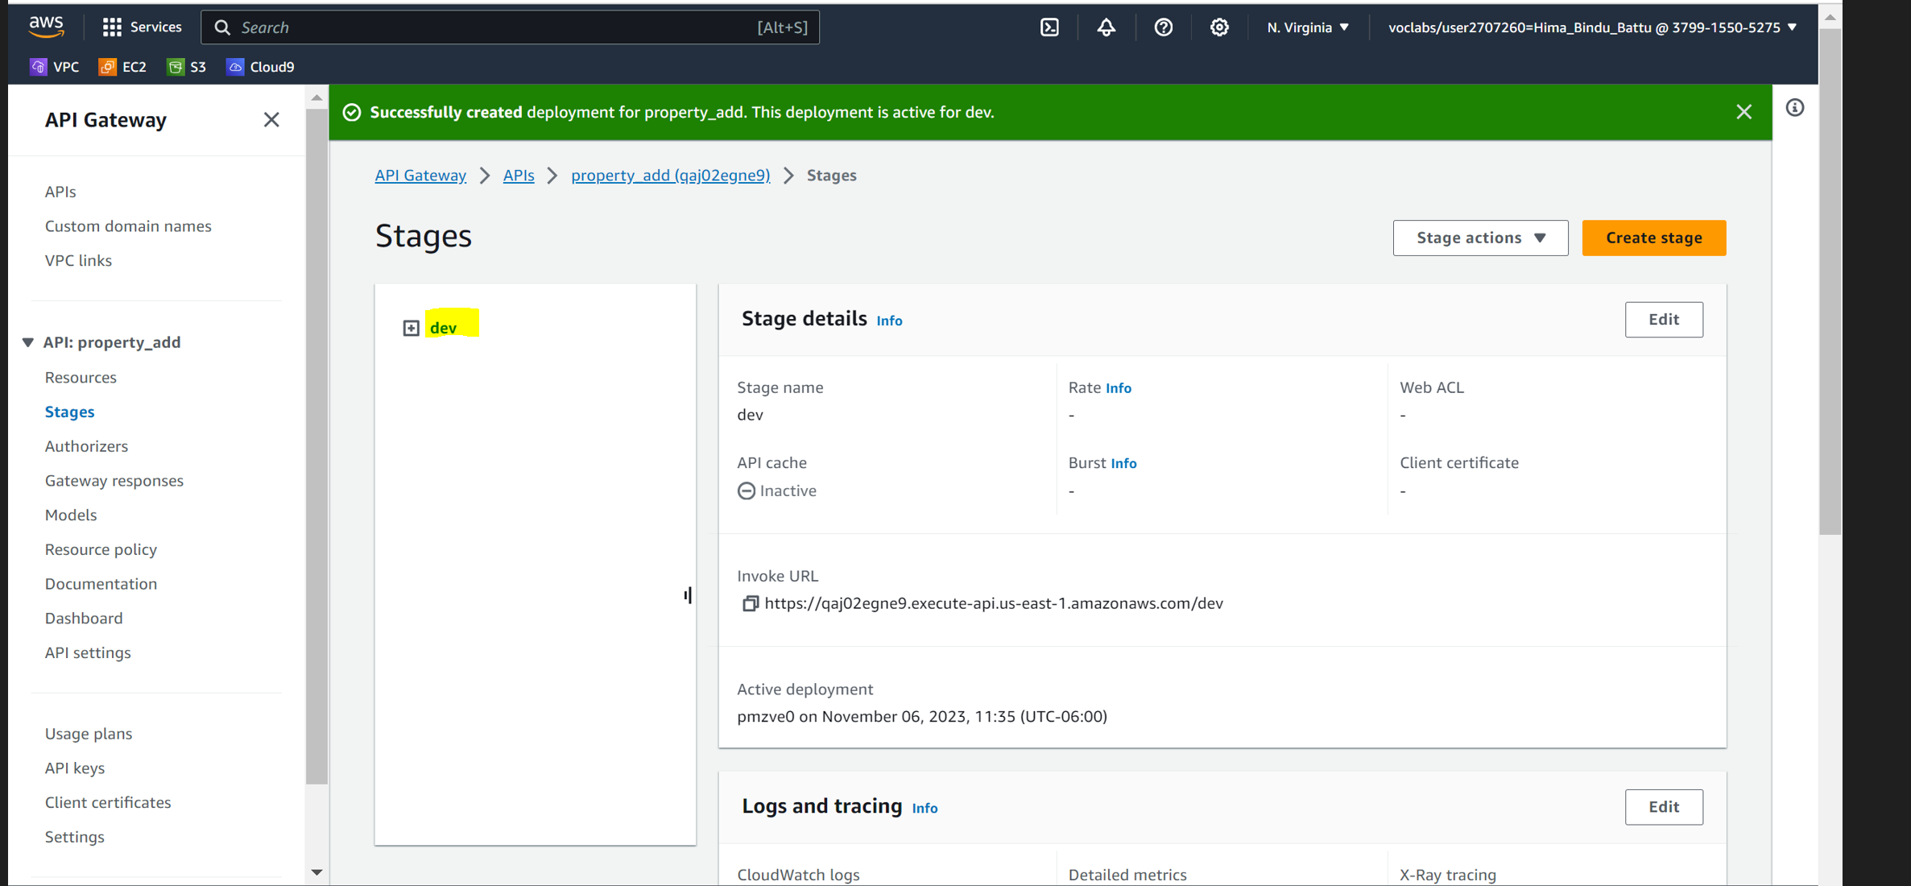

Step-12 Copy the Invoke URL from the Stages- POST method (dev/newproperty) and paste the URL in the Javascript file and run the .js file

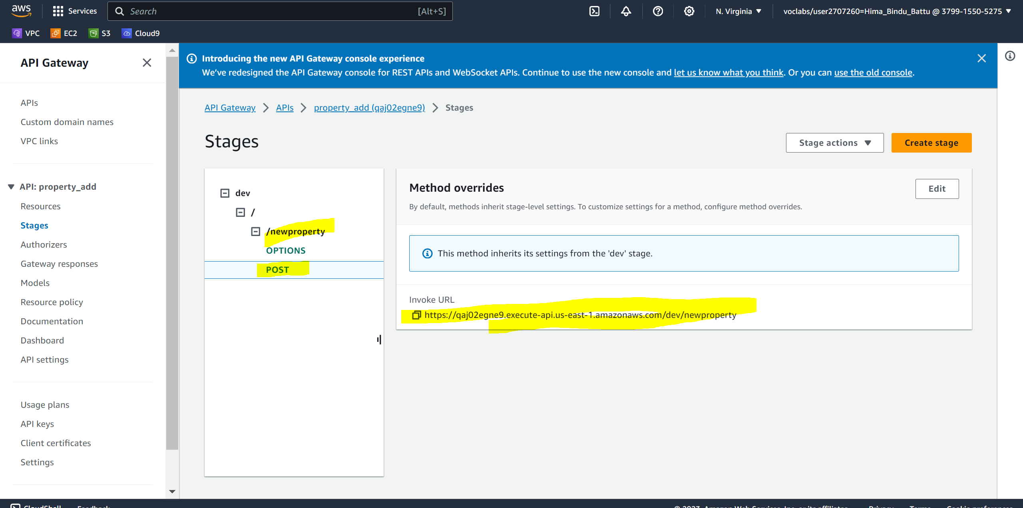

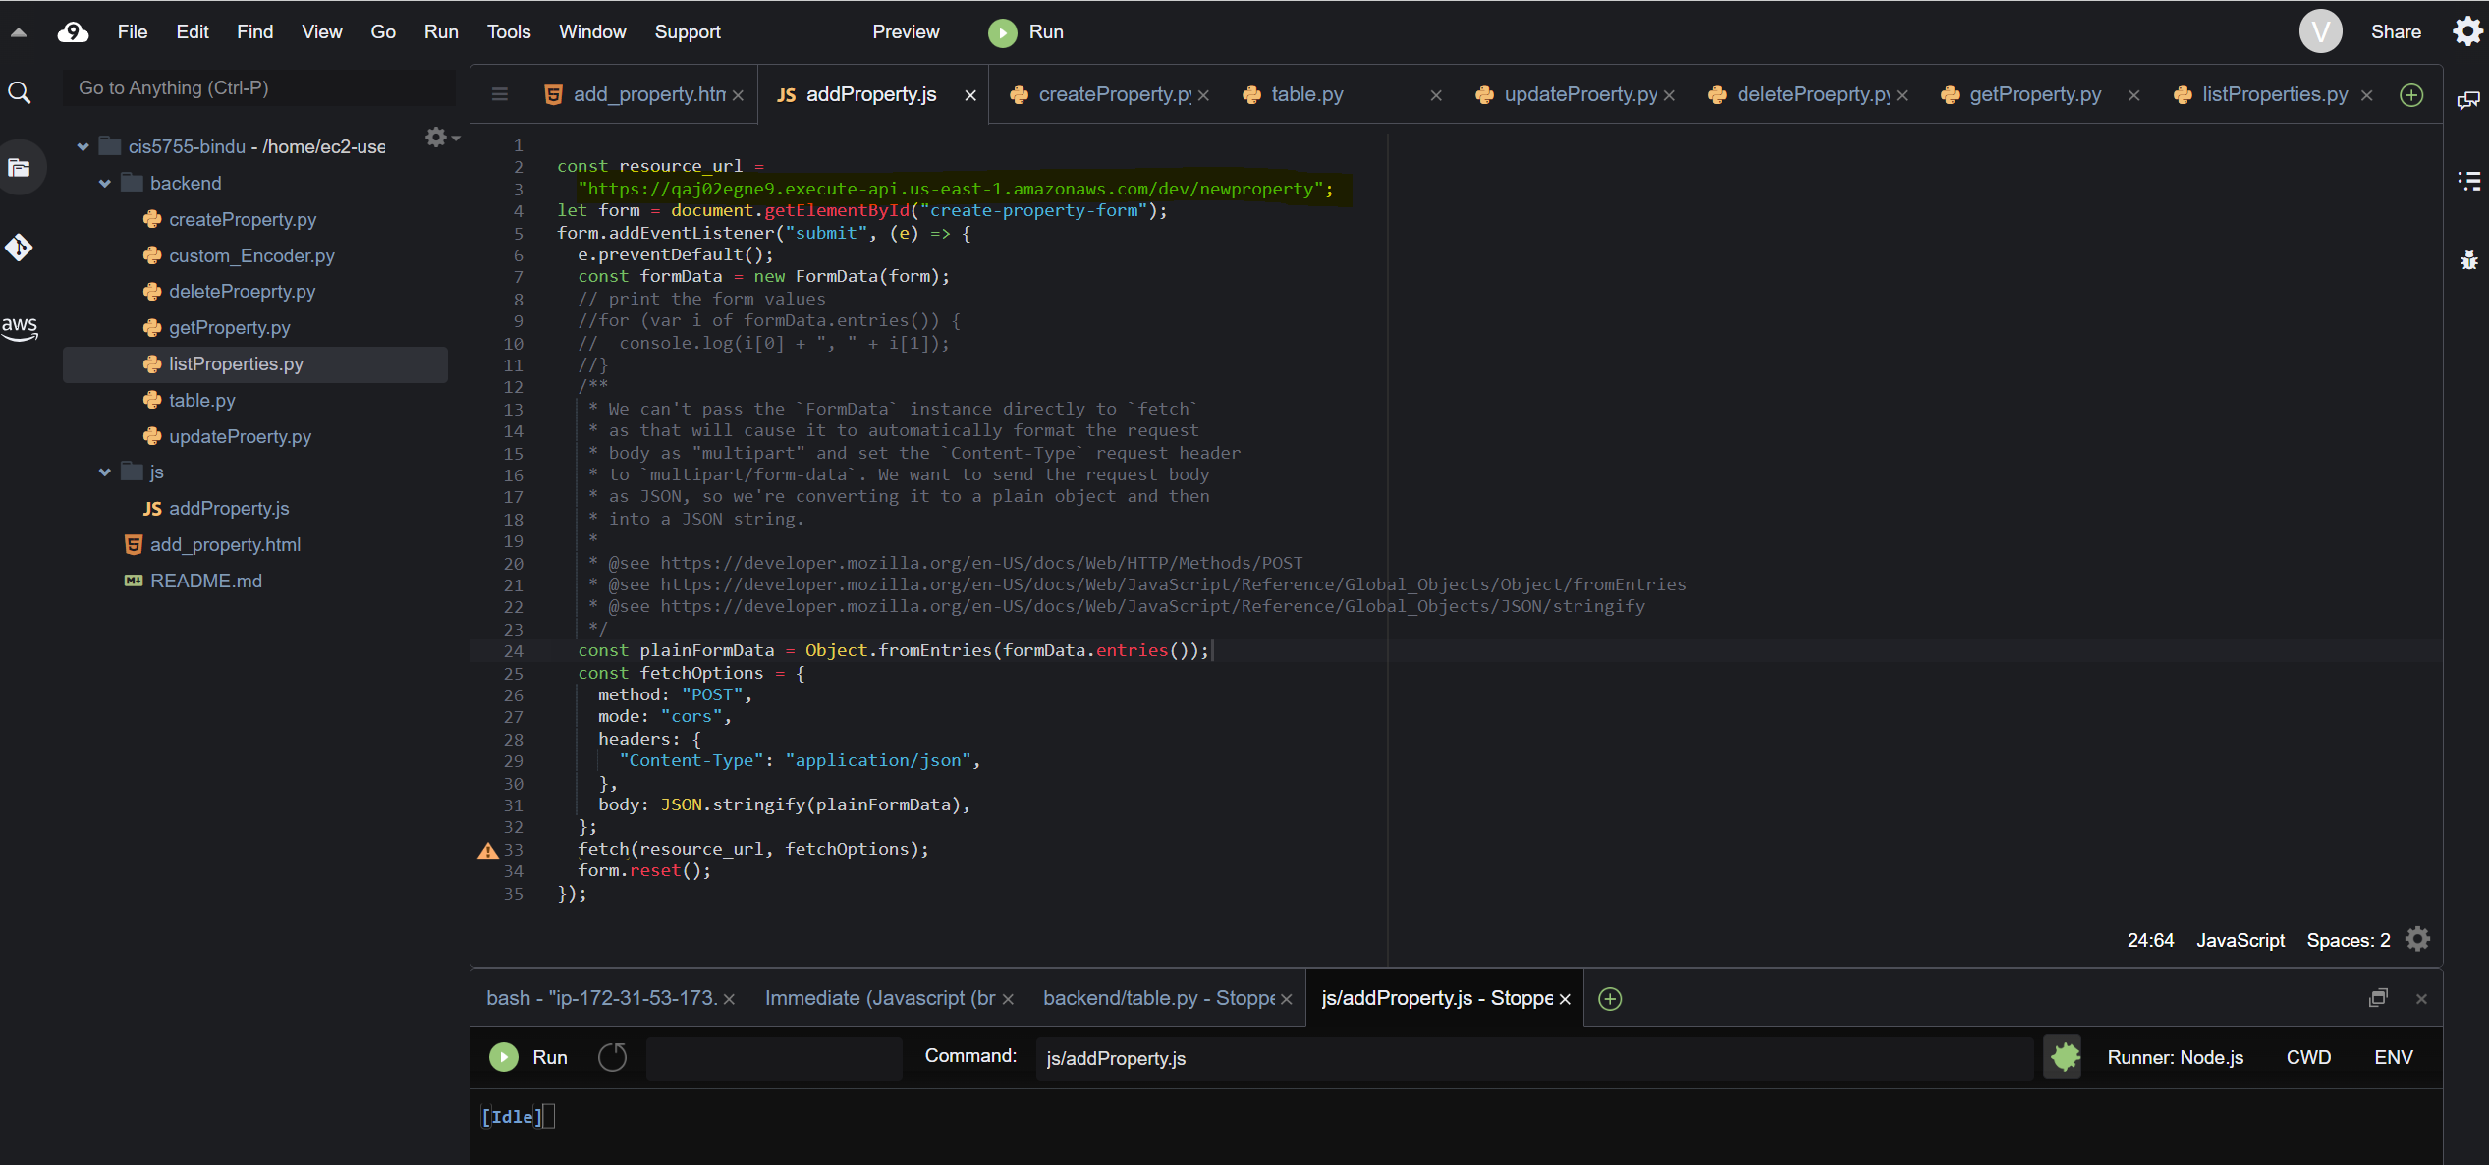

Step-13 **Test for the application**-Test by giving the values in the add_property.html file and check if the values are being Posted to the Dyanamo DB.

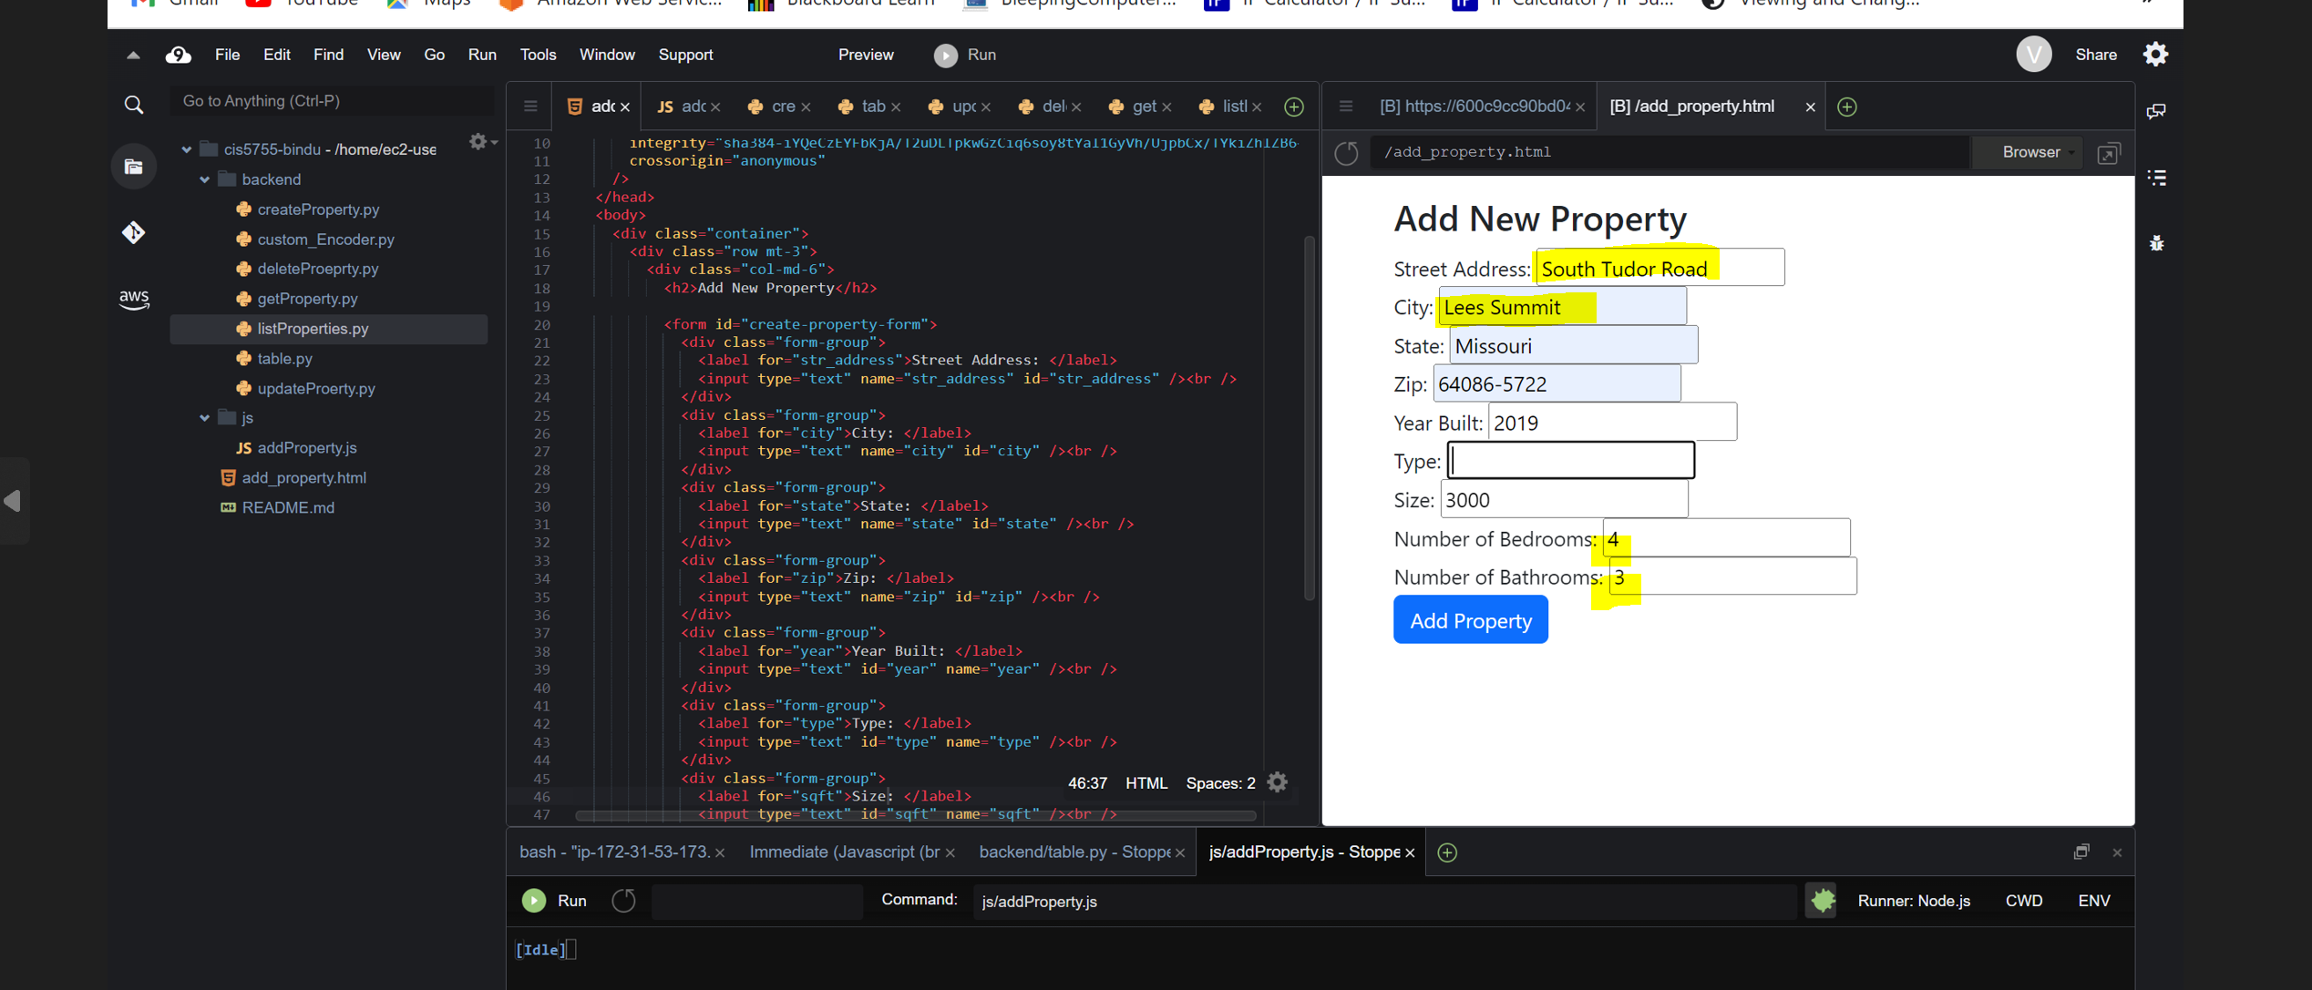

The final application -Values from the add_property.html, the Test Values are being reflected in the Dyanamo DB

